Enhanced Algebra: Concepts & Connections – Jabal Moss
Lesson Plan Week of February 24 - 28, 2025

Standards |  | 8.FGR.7 Justify and use various strategies to solve systems of linear equations to model and explain real-life phenomena.  - 8.FGR.7.1 Interpret and solve relevant mathematical problems leading to two linear equations in two variables.  - 8.FGR.7.2 Show and explain that solutions to a system of two linear equations in two variables correspond to points of intersection of their graphs, because the points of intersection satisfy both equations simultaneously.  - 8.FGR.7.3 Approximate solutions of two linear equations in two variables by graphing the equations and solving simple cases by inspection.  - 8.FGR.7.4 Analyze and solve systems of two linear equations in two variables algebraically to find exact solutions.  - 8.FGR.7.5 Create and compare the equations of two lines that are either parallel to each other, perpendicular to each other, or neither parallel nor perpendicular.  A.PAR.4 Create, analyze, and solve linear inequalities in two variables and systems of linear inequalities to model real-life phenomena.  - A.PAR.4.1 Create and solve linear inequalities in two variables to represent relationships between quantities including mathematically applicable situations; graph inequalities on coordinate axes with labels and scales.  - A.PAR.4.2 Represent constraints of linear inequalities and interpret data points as possible or not possible.  - A.PAR.4.3 Solve systems of linear inequalities by graphing, including systems representing a mathematically applicable situation.  MP.1 Make sense of problems and persevere in solving them. MP.2: Reason abstractly and quantitatively, MP.4: Model with mathematics, MP.7 Look for and make use of structure.MP.1 Make sense of problems and persevere in solving them. MP.2: Reason abstractly and quantitatively, MP.4: Model with mathematics, MP.7 Look for and make use of structure.
Vocabulary |  | 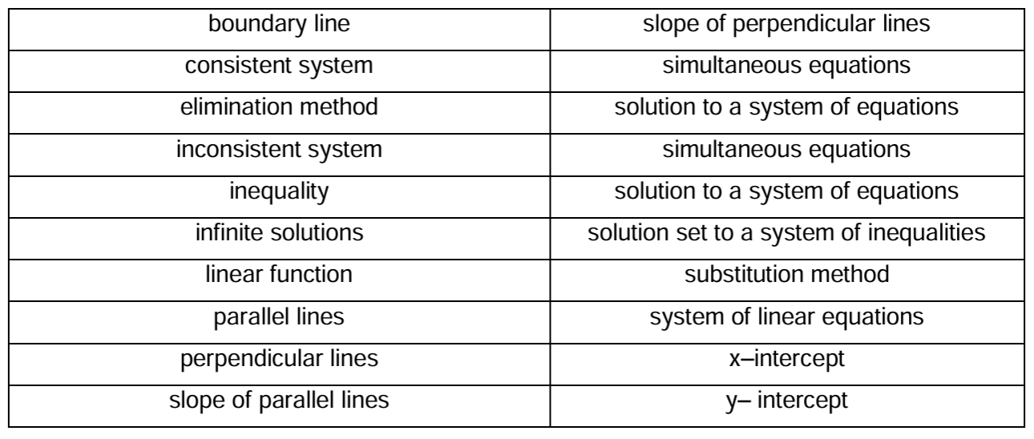
District/State Assessment: |  |  |  |  | Formative Assessment: |  |  |  | Summative Assessment:
☐CMA1  ☐CMA2  ☐CMA3 |  |  | ☐iReady Diagnostic  ☐GMAs |  | ☐Quiz  ☒Quick Write  ☒Check for Understanding |  | ☐Performance Task  ☐Up and Stuck  ☒Exit Ticket |  | ☐Unit Test  ☐Mid Unit Test  ☐Vocabulary Test |  | ☐Project  ☐Culminating Task
 | Learning Target |  |  | Engage |  | Explore/Explain |  | Apply |  | Reflect |  | Success Criteria
Monday  (02/24) | I AM LEARNING TO…  GRAPH linear inequalities in two variables and DETERMINE the solutions by analyzing the graph. |  |  | DO NOW:  Number Sense Routine  ENGAGE:  Error Analysis |  | EXPLORE:  Different Forms of Inequalities (Slope-Intercept Form and Standard Form) |  | EXTEND:  Station Rotation-  Independent Station:  More Practice Task  Reteach Station:  Misconceptions Roundtable  Technology Station:  Progress Learning |  | EVALUATE:  5-question assessment |  | I CAN EXPLAIN how to…  WRITE an inequality in slope-intercept and standard form; CORRECTLY graph the boundary line for a linear inequality and DETERMINE and SHADE the appropriate half-plane.
Tuesday  (02/25) | I AM LEARNING TO…  WRITE and GRAPH systems of linear inequalities, SOLVE real-world phenomena, and DETERMINE the solution region. |  |  | DO NOW:  Number Sense Routine  ENGAGE:  CREATE-THINK-PAIR-SHARE Activity |  | EXPLORE:  SPARK YOUR LEARNING – Arcade Games Task |  | APPLY:  Build Understanding Task (Problems 1-4) |  | REFLECT:  HMH - Check for Understanding |  | I CAN EXPLAIN how to…  WRITE and GRAPH linear inequalities, FIND the overlapping region that satisfies both inequalities, and VERIFY whether specific points are solutions.
Wednesday  (02/26) | I AM LEARNING TO…  WRITE and GRAPH systems of linear inequalities, SOLVE real-world phenomena, and DETERMINE the solution region. |  |  | DO NOW:  Number Sense Routine  ENGAGE:  From Standard Form to Slope-Intercept Form Practice |  | EXPLORE:  One-Page Reteach Lesson |  | EXTEND:  Station Rotation-  Independent Station:  More Practice Task  Reteach Station:  Misconceptions Roundtable  Technology Station:  Progress Learning |  | REFLECT:  5 question assessment |  | I CAN EXPLAIN how to…  WRITE and GRAPH linear inequalities, FIND the overlapping region that satisfies both inequalities, and VERIFY whether specific points are solutions.
Thursday  (02/27) | I AM LEARNING TO…  JUSTIFY and USE multiple strategies to solve systems of linear equations and inequalities, both graphically and algebraically, to MODEL and EXPLAIN real-world phenomena. |  |  | DO NOW:  Number Sense Routine  ENGAGE:  Guided Discussion |  | EXPLORE:  Create real-life phenomena using system of equations and inequalities to build an understanding task. |  | EXTEND:  Unit Review Guide (Work in Groups) |  | EVALUATE:  Up and Stuck Challenge |  | I CAN EXPLAIN how to…  SOLVE systems of linear equations by finding the intersection point; UNDERSTAND that the intersection point represents the common solution for both equations; CREATE systems (linear and inequalities) for real-life phenomena and CONSTRUCT parallel and perpendicular lines.
Friday  (02/28) | I AM LEARNING TO…  SHOW what I know as it relates to solving systems of linear equations and inequalities. |  |  | DO NOW:  Number Sense Routine  ENGAGE:  Questions and Answers |  | EXPLAIN:  Unit Assessment |  | APPLY:  Unit Assessment |  | REFLECT:  Unit Assessment |  | I CAN EXPLAIN how to…  SOLVE systems of linear equations and inequalities.
Study Skills…
 | Teacher Led | Personalized Learning | Student Station
Monday  (02/24) | Skill Building Station | i-Ready Reading Pathway | Silent Reading/Make-up Work
Tuesday  (02/25) | Skill Building Station | i-Ready Reading Pathway | Silent Reading/Make-up Work
Wednesday  (02/26) | Team 8A Data Chats | Team 8A Data Chats | Team 8A Data Chats
Thursday  (02/27) | Understanding Solving Equations | i-Ready Math Lesson | Silent Reading/Make-up Work
Friday  (02/28) | Understanding Solving Equations | i-Ready Math Lesson | Silent Reading/Make-up Work

